POCKETSMAT AI
YOUR SMART BUDGET & RECOMMENDATION ASSISTANT

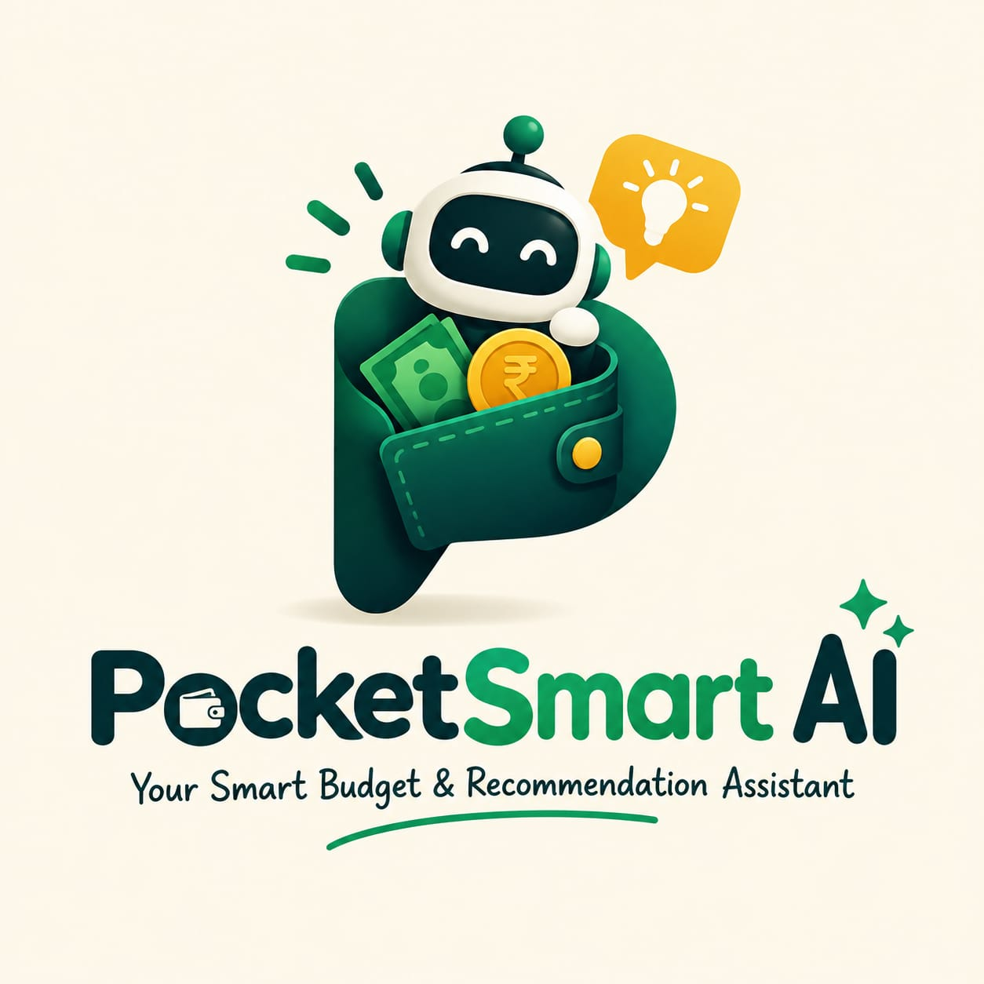

Academic Year: 2026–2027



GOVERNMENT ARTS AND SCIENCE COLLEGE
WIMCO NAGAR
THIRUVOTTRIYUR, CHENNAI-19
Team ID : SWTID-2026-5358

POCKETSMAT AI: YOUR SMART BUDGET & RECOMMENDATION ASSISTANT

Team Size : 4


Team Leader : Isha dhaslima J
Team member : Gopika P
Team member : Kowsalya M
Team member : Gayathri M

S.No. | CONTENTS
1 | Introduction
2 | Problem Statement
3 | Objectives
4 | Scope of the Project
5 | Existing System
6 | Proposed System
7 | Technologies Used
8 | System Requirements
9 | System Architecture
10 | System Workflow
11 | Module Description
12 | Database Design
13 | Screenshot
14 | Advantages
15 | Limitations
16 | Future Enhancement
17 | Conclusion

1. INTRODUCTION:
Pocket Smart AI: Your Smart Budget & Recommendation Assistant is an AI-based application developed to help users manage their personal finances efficiently. It allows users to record their income and expenses, monitor their spending, and manage their budget in an organized manner.
The system analyzes the user's spending patterns and provides smart recommendations to support better financial decisions. It helps users understand their expenses, control unnecessary spending, and plan their budget effectively.
The main aim of Pocket Smart AI is to provide a simple, intelligent, and user-friendly solution for personal budget management.

2. PROBLEM STATEMENT:
Managing personal finances is an important part of everyday life. However, many people find it difficult to properly track their income, expenses, savings, and monthly budgets. When expenses are recorded manually or not tracked regularly, users may lose awareness of where their money is being spent. This can lead to unnecessary spending and difficulty in achieving financial goals.
Another common problem is that traditional budget management methods mainly focus on recording expenses and do not provide personalized suggestions. Users may know how much they have spent, but they may not know which expenses can be reduced or how to plan their remaining budget effectively.
Pocket Smart AI: Your Smart Budget & Recommendation Assistant is developed to address these challenges. The system provides a centralized platform for recording and monitoring financial activities. It helps users organize their income and expenses and provides a clear view of their spending patterns.
The system also uses AI-based recommendations to provide useful suggestions according to the user's budget and spending behaviour. These recommendations can help users identify unnecessary expenses, control their spending, and plan their budget more effectively.
The main problem addressed by this project is the lack of a simple, intelligent, and personalized system for everyday budget management. PocketSmart AI aims to make financial tracking easier and help users develop better budgeting habits through smart recommendations.

3. OBJECTIVES:
The main objective of PocketSmart AI: Your Smart Budget & Recommendation Assistant is to help users manage their personal finances in a simple and effective manner.
The key objectives of the project are:
- To record and manage user income and expenses.
- To help users create and monitor their budgets.
- To analyze spending patterns and financial activities.
- To identify unnecessary or excessive spending.
- To provide smart and personalized budget recommendations.
- To help users improve their spending habits.
- To provide a simple and user-friendly interface for financial management.
- To support users in making better day-to-day financial decisions.

4. SCOPE OF THE PROJECT:
The scope of PocketSmart AI is to provide users with a simple and intelligent platform for managing their personal budgets. The system can be used to record income and expenses, set budgets, and monitor spending activities.
It can analyze the user's spending patterns and provide recommendations for better budget management. The application can also help users identify areas where unnecessary expenses can be reduced.
In the future, the system can be enhanced with features such as advanced financial analytic, savings goal tracking, personalized alerts, and improved AI-based recommendations. Thus, PocketSmart AI can serve as a useful tool for developing better financial management habits.

5. EXISTING SYSTEM:
In the existing system, users generally manage their personal budgets using manual records, notebooks, spreadsheets, or basic expense-tracking applications. These methods can help users record their income and expenses, but they may require regular manual updates and calculations.
Traditional systems mainly focus on storing financial information and showing basic expense details. They may not provide personalized recommendations based on the user's spending behaviour. As a result, users may find it difficult to identify unnecessary expenses or understand how to improve their budgeting habits.
The existing approach also provides limited intelligent analysis of spending patterns. Therefore, there is a need for a more automated and intelligent budget management system that can analyze user data and provide useful recommendations.

6. PROPOSED SYSTEM:
The proposed system, Pocket Smart AI: Your Smart Budget & Recommendation Assistant, is designed to provide an intelligent and user-friendly solution for personal budget management. The system allows users to record their income and expenses and monitor their spending activities in an organized manner.
PocketSmart AI analyzes the user's financial information and spending patterns to provide suitable budget recommendations. It helps users understand their expenses, identify unnecessary spending, and manage their available budget more effectively.
The system reduces the need for manual calculations and provides important financial information in an easy-to-understand format. By combining budget tracking with AI-based recommendations, PocketSmart AI helps users develop better financial management habits and make informed day-to-day budgeting decisions.

7. TECHNOLOGIES USED:
The PocketSmart AI: Your Smart Budget & Recommendation Assistant project uses modern technologies to provide an interactive and intelligent budget management system.
- Front end: Used to create the user interface and provide easy interaction with the application.
- Backend: Handles user requests, budget calculations, expense management, and application logic.
- Database: Stores user information, income, expenses, budget details, and related records.
- Artificial Intelligence: Used to analyze spending patterns and generate suitable budget recommendations.
- API: Helps different components of the application communicate and exchange data.
These technologies work together to provide a simple, responsive, and intelligent platform for personal budget management.

8. SYSTEM REQUIREMENTS:
Hardware Requirements
- Processor: Intel Core i3 or above
- RAM: Minimum 4 GB
- Storage: Minimum 10 GB free space
- Display: Standard HD Monitor
- Internet: Stable Internet Connection
Software Requirements
- Operating System: Windows 10/11 or equivalent
- Frontend: HTML, CSS, JavaScript
- Backend: Suitable server-side technology
- Database: Suitable database management system
- Development Environment: Visual Studio Code or equivalent IDE
- Browser: Google Chrome, Microsoft Edge, or Mozilla Firefox
These requirements provide a suitable environment for developing, running, and testing the PocketSmart AI application efficiently.

9. SYSTEM ARCHITECTURE:
The PocketSmart AI system follows a simple architecture that connects the user interface, application logic, database, and AI-based recommendation components.
The User Interface allows users to enter income, expenses, and budget details. These details are processed by the Back end/Application Layer, which performs the required calculations and manages the application functions.
The Database Layer stores user information, expense records, income details, and budget information. The AI Recommendation Module analyzes the available financial data and generates suitable recommendations based on the user's spending patterns.
The overall flow is:
User → User Interface → Backend → Database → AI Recommendation Module → Results & Suggestions → User
This architecture helps the system manage financial data efficiently and provide personalized budget recommendations.

10. SYSTEM WORKFLOW:
The PocketSmart AI system follows a simple workflow to help users manage their budget and receive personalized recommendations.
- User Registration/Login: The user accesses the application and provides the required details to enter the system.
- Enter Financial Details: The user adds income, expenses, and budget information.
- Data Processing: The system processes and organizes the entered financial data.
- Expense Analysis: The system analyzes the user's spending patterns and compares expenses with the planned budget.
- AI Recommendation: Based on the analyzed data, the AI module generates suitable budget and spending recommendations.
- Display Results: The system displays budget information, expense details, and recommendations to the user.
- Budget Management: The user can review the suggestions and manage future spending accordingly.

11. MODULE DESCRIPTION:
The PocketSmart AI system is divided into different modules, with each module performing a specific function.
1. User Management Module
This module manages user access and basic user information. It allows users to access their personal budget details securely.
2. Income Management Module
This module allows users to enter and manage their income details. The recorded income is used for calculating the available budget.
3. Expense Management Module
Users can add and track their daily expenses under different categories. This helps them understand where their money is being spent.
4. Budget Management Module
This module helps users set a budget and monitor their expenses against the planned amount.
5. AI Recommendation Module
The AI module analyzes spending patterns and provides suitable suggestions to help users control unnecessary expenses and manage their budget.
6. Dashboard Module
The dashboard presents important financial information such as income, expenses, remaining budget, and recommendations in an easy-to-understand format.

12. DATABASE DESIGN:
The database of PocketSmart AI is used to store and manage the financial information required by the application. It maintains user details, income records, expense records, and budget information in an organized manner.
The main database tables/collections can include:
1. User
Stores basic user information such as:
- User ID
- Name
- Email
- Password
2. Income
Stores the income details entered by the user:
- Income ID
- User ID
- Income Amount
- Income Source
- Date
3. Expense
Stores details of the user's expenses:
- Expense ID
- User ID
- Expense Category
- Amount
- Description
- Date
4. Budget
Stores the user's planned budget:
- Budget ID
- User ID
- Budget Amount
- Category
- Period
The stored data is used by the application to calculate spending, monitor budgets, and generate suitable AI-based recommendations.

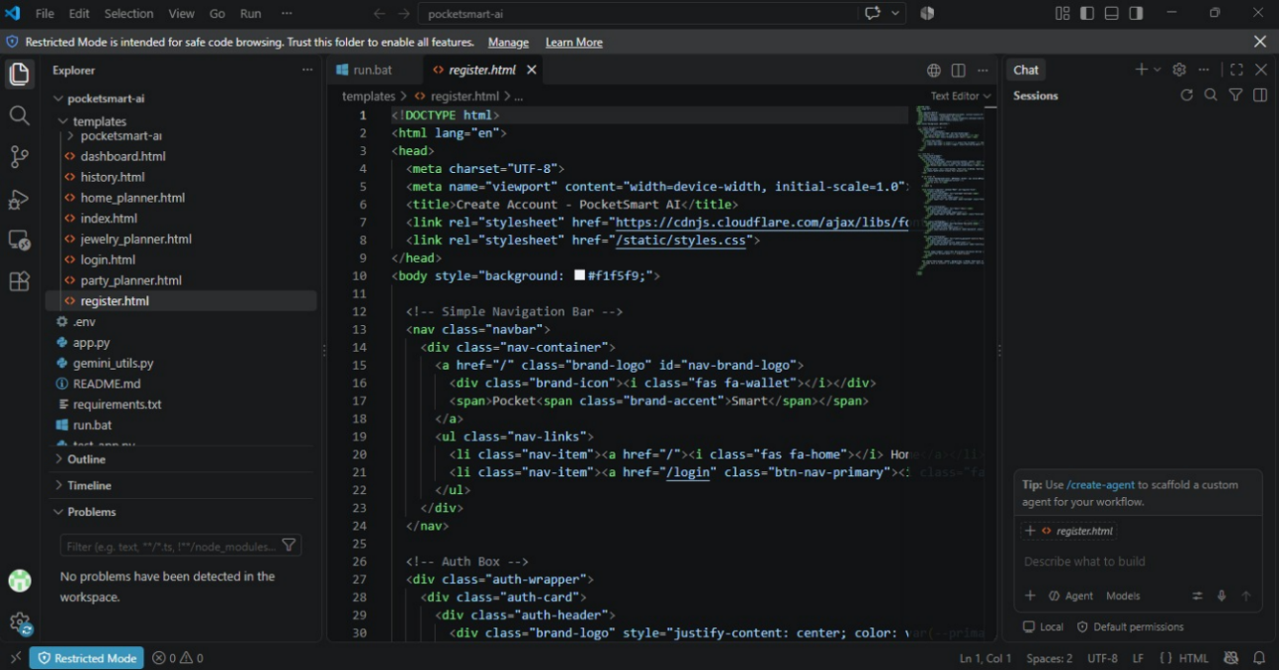

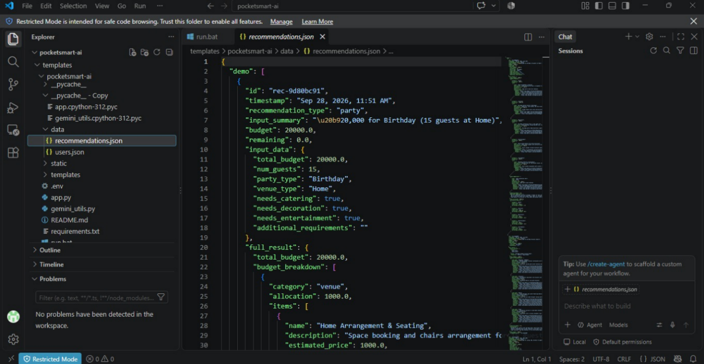

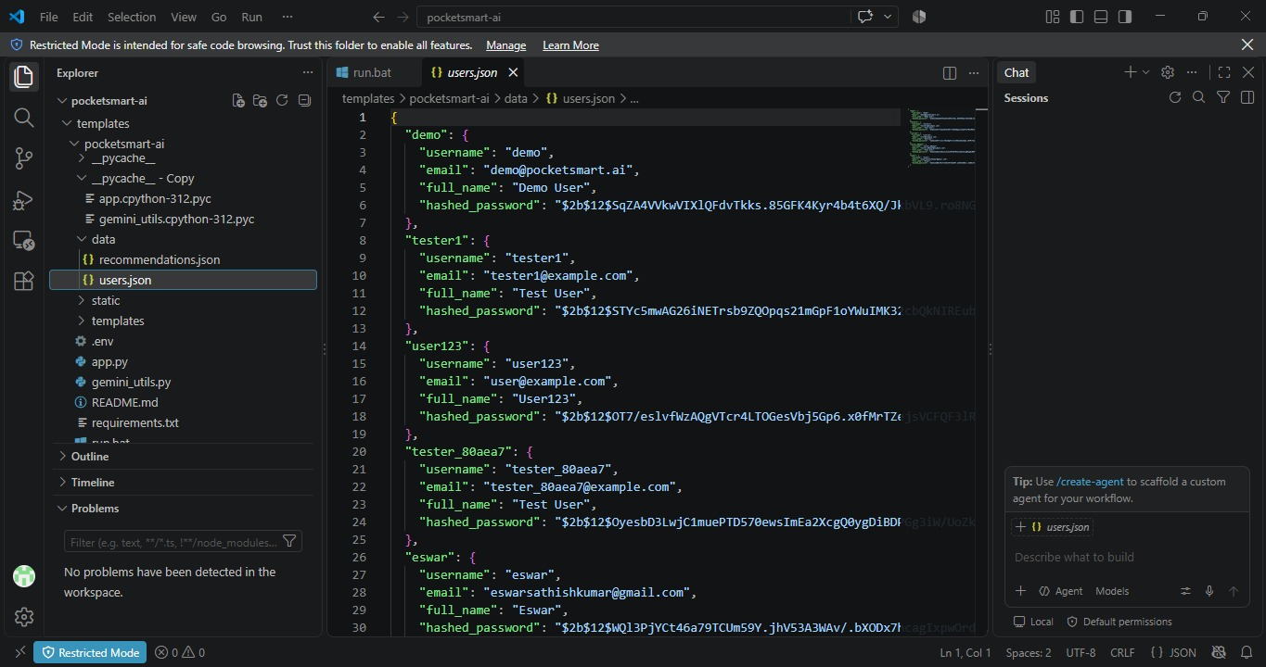

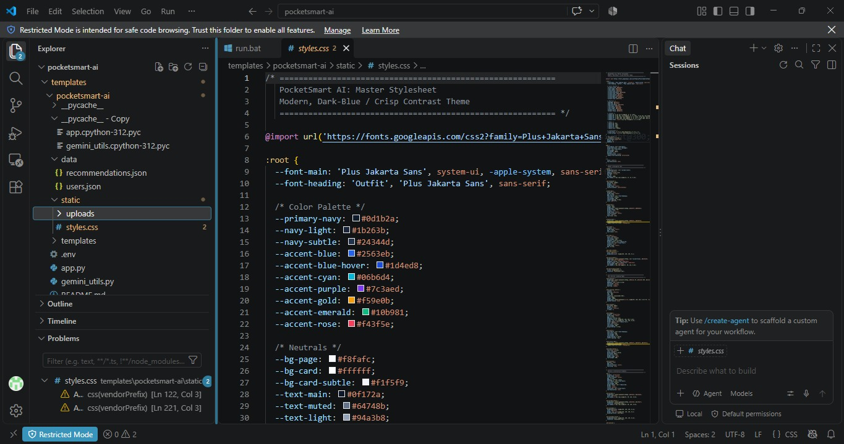

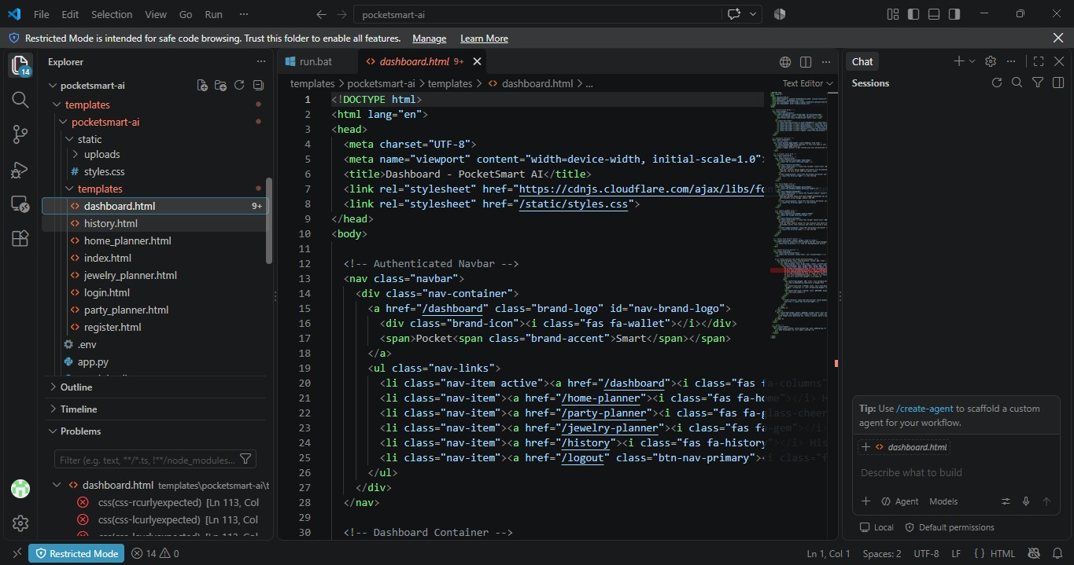

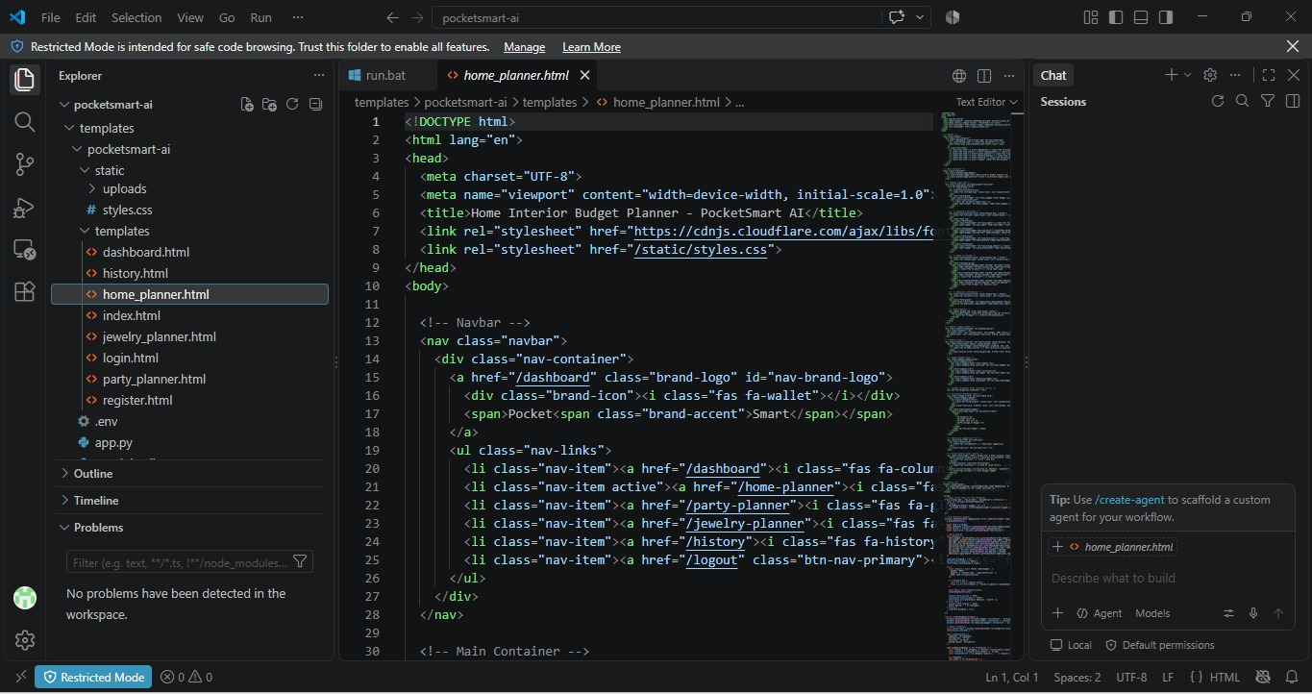

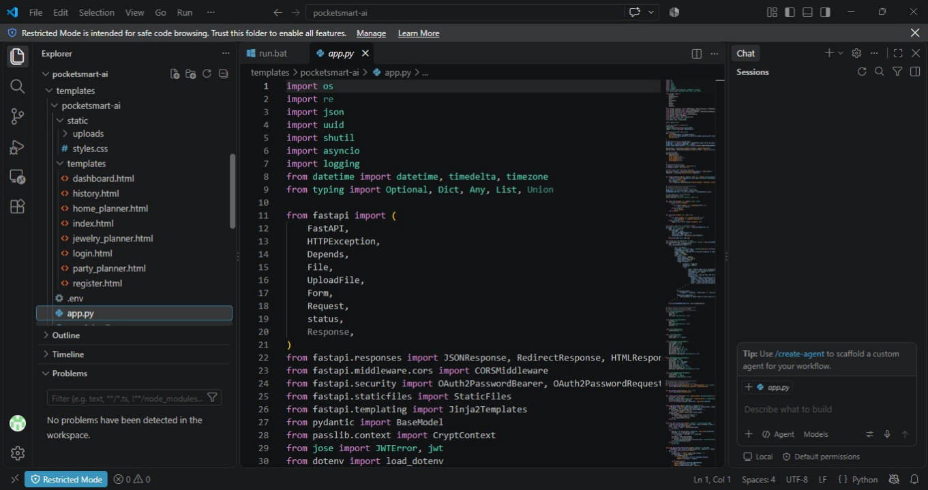

14. ADVANTAGES:
The PocketSmart AI system provides several advantages for effective personal budget management.
- Helps users easily track income and expenses.
- Provides a clear view of overall spending habits.
- Helps users set and monitor their budgets.
- Reduces the need for manual calculations.
- Provides AI-based personalized recommendations.
- Helps identify unnecessary or excessive spending.
- Provides financial information in a simple and organized format.
- User-friendly interface makes the system easy to use.
- Supports users in developing better budgeting habits.
- Helps users make more informed day-to-day financial decisions.

15. LIMITATIONS:
Although PocketSmart AI provides useful features for budget management, the system has some limitations.
- The accuracy of recommendations depends on the financial information entered by the user.
- Incorrect or incomplete data may result in less relevant recommendations.
- The system may require an internet connection for certain AI-based features.
- The recommendations are intended for general budgeting support and may not cover every individual financial situation.
- The effectiveness of the system depends on regular updating of income and expense details.
- Advanced financial features may require further development and additional data.
These limitations can be addressed through future improvements and enhanced AI capabilities.

16. FUTURE ENHANCEMENT:
The PocketSmart AI system can be enhanced with additional features to make budget management more intelligent and convenient.
- Advanced AI Recommendations: Improve recommendations using detailed spending patterns and user preferences.
- Savings Goal Tracking: Allow users to create and monitor specific savings goals.
- Expense Alerts: Send notifications when spending approaches or exceeds the planned budget.
- Financial Reports: Generate monthly and yearly spending summaries with charts and reports.
- Voice-Based Assistance: Allow users to enter expenses or ask budget-related questions using voice commands.
- Mobile Application: Develop a dedicated Android/iOS application for easier access.
- Improved Personalization: Provide recommendations based on individual financial habits and goals.
These enhancements can make PocketSmart AI a more comprehensive and intelligent personal budget management solution.

17. CONCLUSION:
PocketSmart AI: Your Smart Budget & Recommendation Assistant provides a simple and intelligent solution for managing personal finances. The system helps users record their income and expenses, set budgets, monitor spending patterns, and receive AI-based recommendations.
By combining budget management with intelligent analysis, the application helps users understand their financial habits and control unnecessary spending. Its user-friendly approach makes personal budget management easier and more organized.
Overall, PocketSmart AI can serve as a useful tool for developing better budgeting habits and making informed day-to-day financial decisions.

GITHUB LINK: https://github.com/Isha-Dhaslima-23/Pocket-Smart-AI-Budget-Recommendation-Assistant/upload/main

DRIVE LINK: https://drive.google.com/file/d/1Ky_SQRT90dJE8Xiiy9YSvYIDuc6Y0yB0/view?usp=sharing

